**Sprint – 4**

**Team ID: PNT2022TMID10955**

**Task:**

Sensed data is brought to Node-RED and displayed in dashboard

**Steps:**

1. IBM IoT node is used to gather sensor data.

a. Necessary API key is provided to establish connection.

1. Using functions namely Temperature, Humidity and Gas the data is obtained independently and displayed in dashboard.
2. Dashboard Nodes are used to display the sensed data to the user in a portal.

**Sour code:**

|  |  |
| --- | --- |
| Temperature: | msg.payload = msg.payload.Temp;  return msg; |
| Humidity: | msg.payload = msg.payload.Hum;  return msg; |
| Concentration of Gas: | msg.payload = msg.payload.gas; |

return msg;

**Output:**

1. **Data is brought to Node-RED**

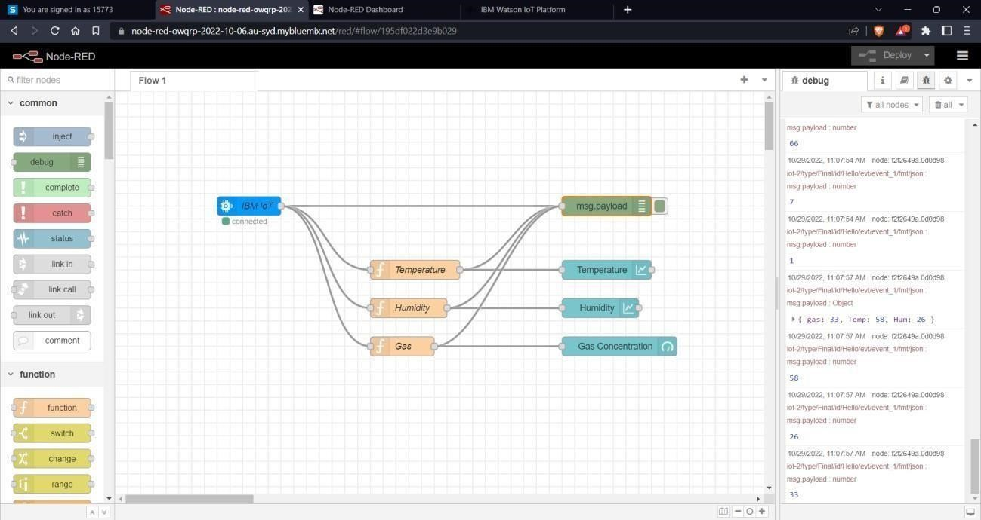

1. **Data is displayed in Dashboard**

